The WITS Geeks
Sprint 4 UML Diagrams Final update

1.Process view -Activity Diagram: Generate report(Custom view).
This is an activity diagram of the Custom View report generation process, representing the process view of the system architecture. It maps the end-to-end workflow—user input, client-side validation, backend authentication, MongoDB aggregation, and result visualisation—showing how the system’s components interact step-by-step to deliver a dynamic analytics report.

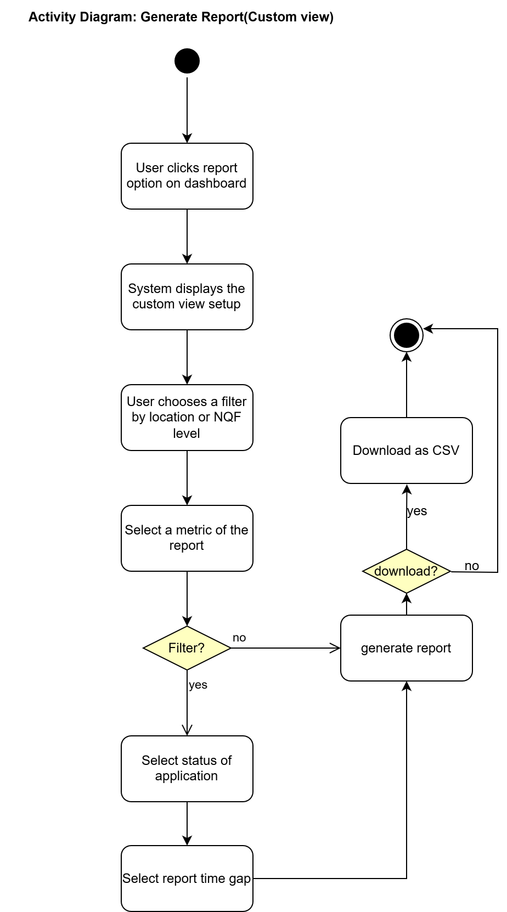
2.logical view- State diagram: User entity
This is a state diagram of the User entity, representing the Logical view of the system architecture for user account status management. It captures the possible states—Active, Inactive, and Disabled—and the transitions triggered by events such as deactivation, reactivation, and soft deletion, illustrating how the system enforces account lifecycle rules.
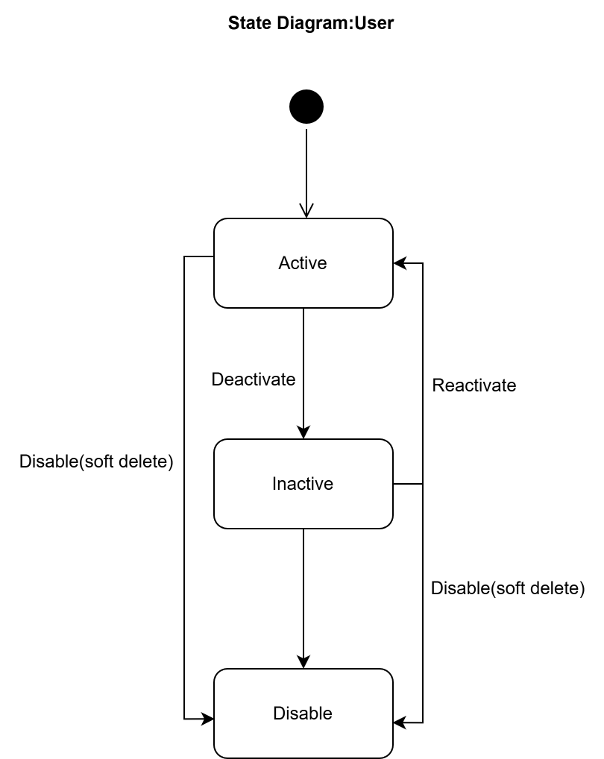

3.logical view-Class Diagram(Final)
The class diagram now includes an AnalyticsReport entity. A single Admin or Provider can generate many reports, but each report is created by exactly one Admin or Provider—a one‑to‑many relationships from the user role to the report.
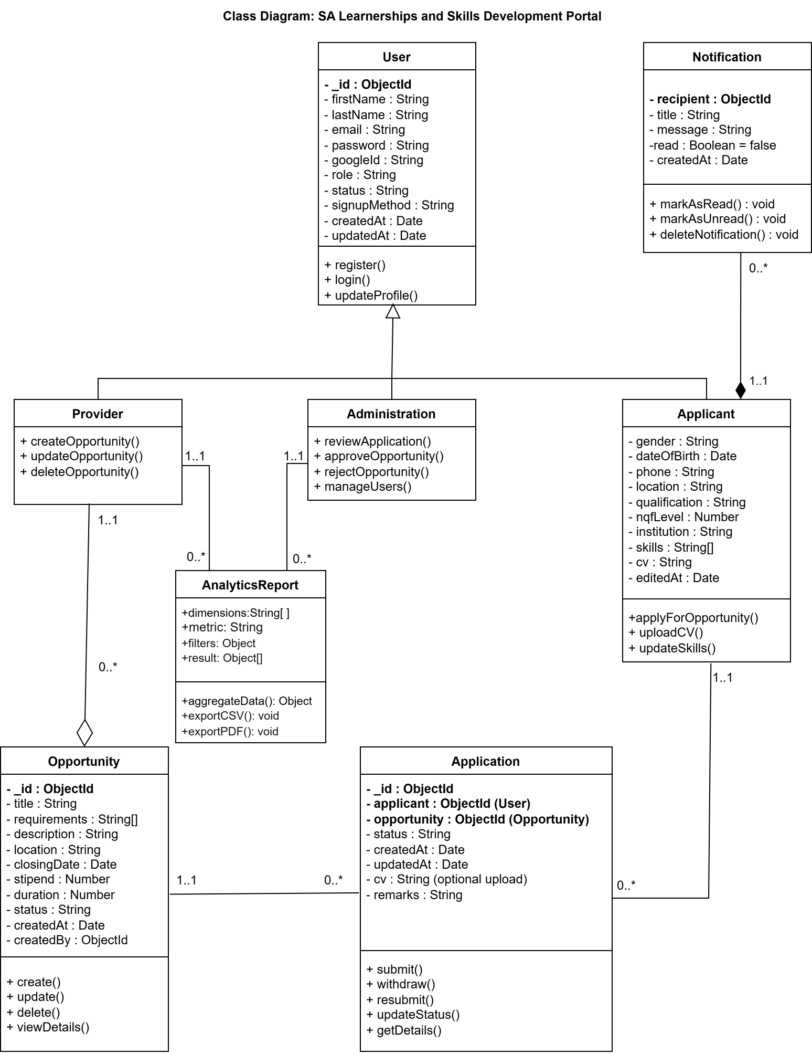

4.Scenario view-Use case Diagram
This use case diagram represents the final set of use cases for the SA Learnerships Portal, encompassing all functional requirements outlined in the project backlog. It captures the scenario view of the system architecture, illustrating how the three primary actors—Applicant, Provider, and Admin—interact with the system to accomplish their respective goals. The diagram covers key processes such as user registration, opportunity management, applicant profile editing, application workflows, notifications, and analytics reporting, providing a complete overview of the system’s external behaviour.
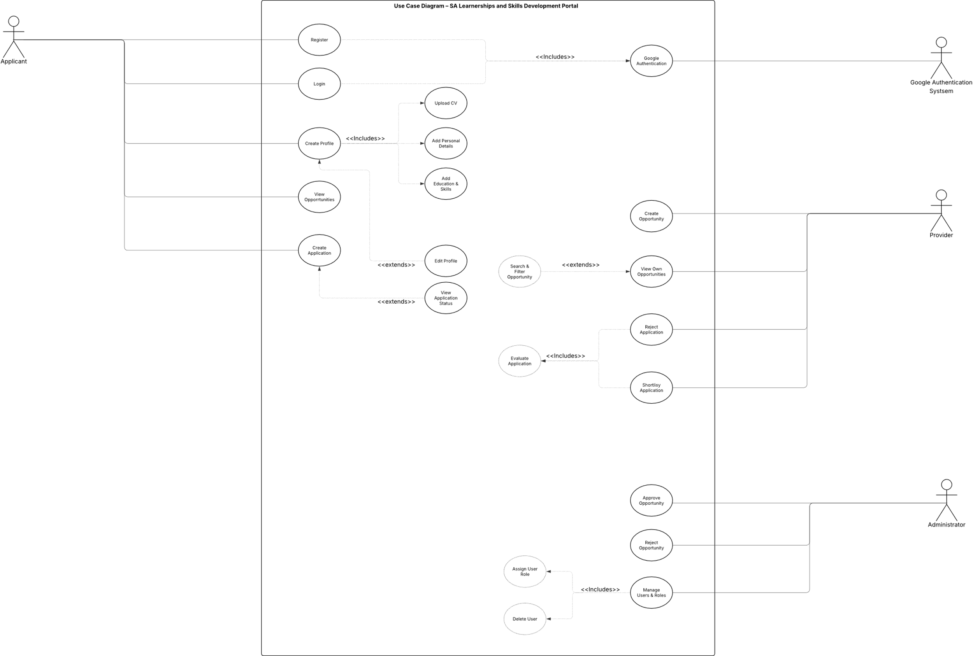

5. Deployment Diagram
This deployment diagram illustrates the physical architecture of the SA Learnerships Portal, representing the physical view of the system. It shows how the frontend and backend are hosted together on an Azure App Service, with standardized data (qualifications, skills, institutions, and locations) loaded at startup and served via API endpoints. The backend communicates with a MongoDB Atlas database for persistent storage and uses Google OAuth for third-party authentication. The diagram also includes the CI/CD pipeline that automates build and deployment on push, providing a complete overview of the system’s production infrastructure.
